**Assignment -3**

Python Programming

| Assignment Date | 6 October 2022 |
| --- | --- |
| Student Name | Prawin R |
| Student Roll Number | 722819104104 |
| Maximum Marks | 2 Marks |

**Question-1:**

Write python code for blinking LED and Traffic lights for Raspberry pi.

**SOLUTION :**

import RPI.GPIO as GPIO

from time import sleep

GPIO.setmode(GPIO.BCM)

GPIO.setup(22, GPIO.OUT)

while True:

GPIO.output(22, GPIO.HIGH)

sleep(1)

GPIO.output(22, GPIO.LOW)

sleep(1)

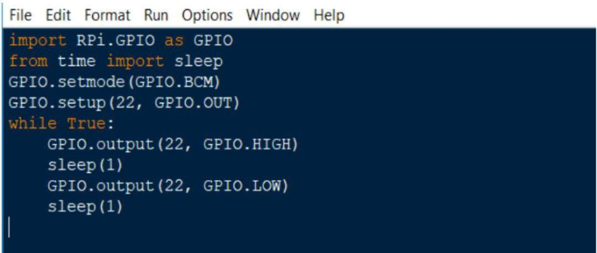

**Question-2:**

Write python code for Traffic lights for Raspberry pi

**SOLUTION :**

import RPI.GPIO as GPIO

GPIO.setmode(GPIO.BCM)

from time import sleep RED, YELLOW,GREEN=9,10,11 GPIO.setup(YELLOW, GPIO.OUT) GPIO.setup(GREEN, GPIO.OUT)

GPIO.setup(RED, GPIO.OUT)

while True: #Red Signal

GPIO.output(RED, HIGH)

sleep(55)

#Yellow Signal

GPIO.output(RED, LOW)

GPIO.output(YELLOW, HIGH)

sleep(5)

#Green Signal

GPIO.output(YELLOW, LOW)

GPIO.output(GREEN, HIGH)

sleep(30)

GPIO.output(GREEN, LOW)

